**Case of the month 1**

A 24-year-old woman was admitted with an episode of palpitation. The episode lasted for an hour or so and she felt near faint with this. There was no history of palpitation or any cardiac history in the past. She was not diabetic, there was no history of hypertension. There was no family history of coronary artery disease. There was no history of sudden death in the family. A 12 lead ECG was recorded by the ambulance crew (Fig1). The palpitation stopped before she presented to the emergency department. A 12 lead was recorded in the emergency department (Fig 2)

Fig1

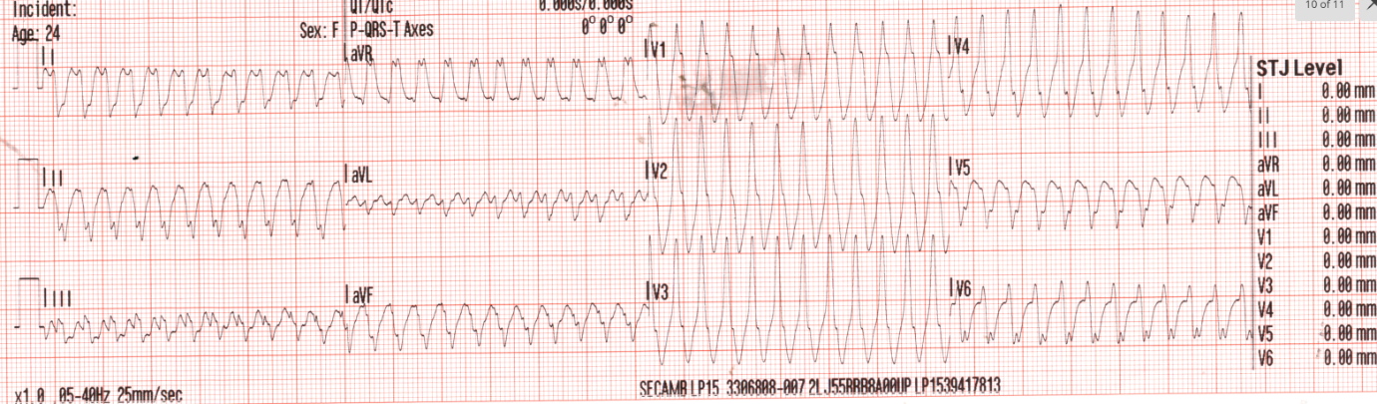

Fig2

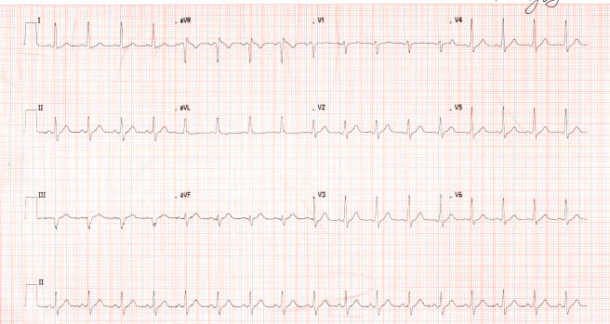

An initial diagnosis of an episode of very fast ventricular tachycardia was made in the emergency department.

An echocardiogram was done in sinus rhythm and it showed structurally normal heart and preserved LV systolic function

**What is the diagnosis**?

It is a broad complex tachycardia in the absence of any overt structural heart disease

Possibilities are

1 VT

2 SVT with aberrancy

3 Atrial tachycardia with conduction via bystander accessory pathway

4 Antidromic AVRT

Extreme axis deviation and QRS duration more than 160msec favour VT. However, there is no evidence of AV dissociation (no capture/fusion beat)

I have not tried Brugada or Vereckei algorithm (algorithm to differentia VT from SVT) as they are complex and high sensitivity/specificity as claimed by the authors are not reproducible. They are also not valid for pre-excited tachycardia

SVT with aberrancy is unlikely as QRS morphology does not conform with typical right or left bundle branch block

Atrial tachycardia (SVT) with bystander accessory pathway is possible

Antidromic AVRT is possible (not a common arrhythmia). It produces broad complex tachycardia as ventricle is activated via accessory pathway.

Now, if we look at sinus rhythm ECG a bit closer, there is a hint of presence of accessory pathway, though PR interval is not that short, there is early QRS transition (r is more than s in lead V2. The transition usually happens in V3/V4) which can happen in septal or left sided pathway

So, we did an adenosine challenge. The following ECG (Fig.3) is after 18 mg adenosine IV in sinus rhythm.

Fig.3

Effect of Adenosine

Adenosine has caused temporary AV node block ( between two arrows) with sinus rhythm conducting through only accessory pathway leading to prominent delta wave and widening of QRS.( see v1 -v5). This proves definitively the presence of accessory pathway and hence the broad complex rhythm was most likely antidromic AVRT rather than VT. Atrial tachycardia with bystander accessory pathway is still a possibility. We will need EP study to differentiate that

She was discharged on Flecainide 50 mg BD and is waiting for an urgent outpatient EP study and ablation

**Case no 2**

This is a simple but rare case

A 31-year-old lady presented to emergency department with palpitations, pressure symptoms in the chest and light-headedness

She had delivered a baby by C. section 1 week ago following failed early induction for foetal growth

BP was normal

ECG showed sinus bradycardia with rate of 33 bpm

Bloods were normal except ALP 426 (was thought to be pregnancy related)

Normal troponin

Echocardiogram showed structurally normal heart with preserved LV function

Had intermittent palpitations during pregnancy and 24 hours tape showed occasional ventricular ectopics

Had US abdomen because of high ALP and it showed an incidental large polyp in gall bladder 13 mm

ECG on admission – Sinus bradycardia with heart rate of 33 bpm

We made a diagnosis of post-partum bradycardia. Heart rhythm was monitored through telemetry. Her symptoms improved gradually with recovery of heart rate and she was discharged after 4 days.

Postpartum maternal sinus bradycardia is a rare but recognised entity. In the absence of pathologic comorbidities this is benign and self-limiting and does not need any intervention and is thought to be due to transient increase in vagal tone

One needs to be careful to rule out post-partum preeclampsia and post-partum cardiomyopathy as they can present with post-partum bradycardia

In a retrospective review of all referrals from obstetric department for bradycardia over a decade at a referral centre performing 10000 deliveries per year, only 44 patients of post- partum bradycardia were identified (hypertensive disorders of pregnancy, heart failure, PP haemorrhage, AV nodal blocking or anti-arrhythmic agents, and non-sinus bradyarrhythmia were excluded) and mean onset of bradycardia occurred 4+_ 7 days postpartum. Our patient presented 7 days post-delivery. (1)

**References**

1. [SEVERE BRADYCARDIA IN PERIPARTUM PERIOD: BENIGN OR PATHOLOGIC? | JACC](https://www.jacc.org/doi/10.1016/S0735-1097%2824%2904403-6)
2. [Post-partum maternal bradycardia: A case series and literature review](https://journals.sagepub.com/doi/pdf/10.1177/1753495X231178407)